

SIMATS ENGINEERING
Saveetha Institute of Medical and Technical Sciences
Chennai- 602105
Student Name: ABINAYASRI K
Reg. No: 1921260133
Course Code: CSA0704
Slot: A
Course Name: Computer Networks
Course Faculty: DR.K.JAISHARMAss
Project Title: PHISHING EMAIL TRAFFIC DETECTION AND AWARENESS SYSTEM
Module Photographs: (3 photographs – Module Photo, Individual student contribution module work in the project and presentation image)
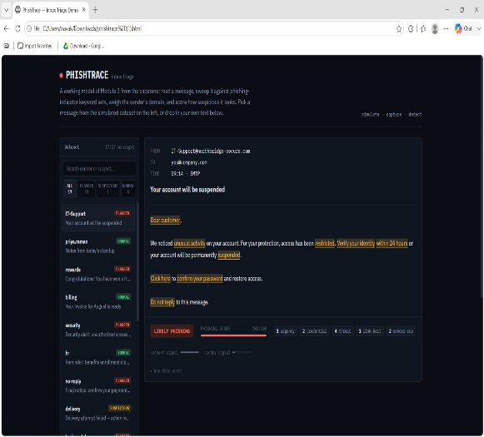

s
PROJECT DESCRIPTION: SECURE ACCESS MANAGEMENT - MODULE 2
The Phishing Email Traffic Detection and Awareness System is a security-focused application developed using Python and Flask to identify and flag phishing attempts within incoming email traffic. It helps users and organizations analyze emails and recognize potentially malicious or deceptive content before it causes harm. Users can provide either a raw email file (.eml) or paste the email header and body content as input. The system extracts key indicators such as sender address, reply-to mismatches, embedded URLs, and attachment types using rule-based parsing techniques. Each extracted indicator is verified by cross-referencing multiple evidence sources such as URL blacklists, domain reputation databases, and SPF/DKIM/DMARC authentication records. Emails are classified as Phishing, Suspicious, or Safe based on the combined evidence. A risk score is calculated by weighing spoofed sender patterns, malicious links, urgency-based language, and authentication failures. The backend uses Python, Flask, Requests, BeautifulSoup4, and SQLite for parsing, verification, and logging of email traffic. The functional prototype provides an easy-to-understand risk percentage, a breakdown of suspicious indicators, and awareness tips to help users identify phishing attempts on their own. The system promotes safer email practices and can be further enhanced with NLP-based content analysis, machine learning classifiers, and real-time email gateway integration.

Student Signature | Guide Signature
sss

